Tool 4: Climate risk and opportunity assessment workbook – handbook

This guidance Is designed to provide you with detailed instructions on how to complete a climate risk assessment workbook for a project. This workbook has been designed to support the assessment of climate change vulnerabilities and risks in infrastructure and built environment projects.
It gives an overview of each of the sections included in the workbook, as well as a step by step guide to each of the sections, to complete it.
The workbook has been designed to allow practitioners to assess a wide range of climatic changes. However, given the wide range of variables included, we suggest that sustainability specialists define the variables in scope of the assessment based on their particular project, and general research on the main ways in which they may be affected, prior to engaging others in the wider assessment process.
The workbook does not include an assessment of 'adaptive capacity' (the ability to prepare, respond and recover), due to the challenges associated with quantifying it, and because the design and delivery of infrastructure or the built environment offers limited opportunities to change this. However, the ability of individuals to prepare, respond and recover to extreme weather events and climate change is significant, and should be considered as part of a more holistic approach to managing risk, as set out in step 5.

Overview of the process
The overall process comprises five steps:
Step 1. Define the project and scope
Enter basic information about the project and list all the assets and activities, inputs, outputs and transport links in scope of the assessment.
Step 2. Assess vulnerability  Assess the vulnerability of the on-site assets and processes, inputs, outputs, and transport links to weather conditions and climate change. | 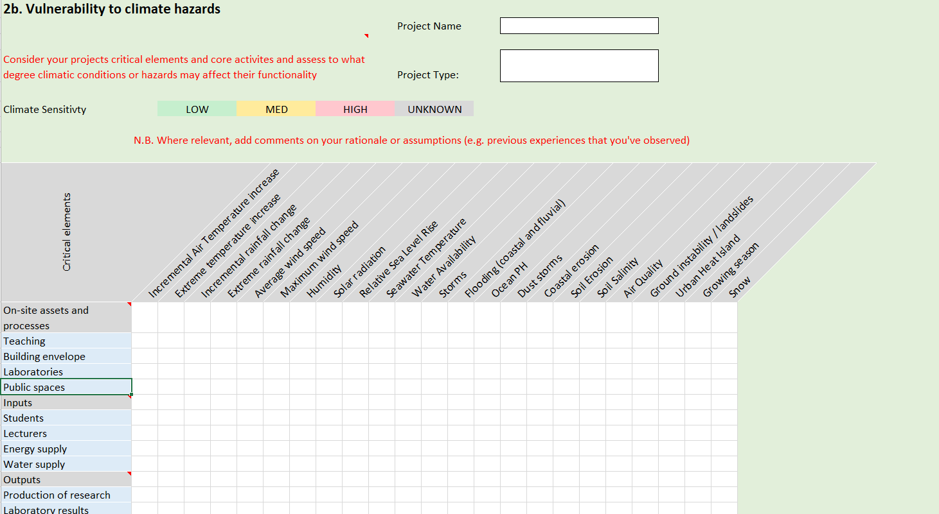
Step 3. Assess hazard and exposure  Assess to what degree these elements are likely to be exposed to the listed weather conditions and climate hazards - today and in a future scenario related to the expected lifetime of the project. | 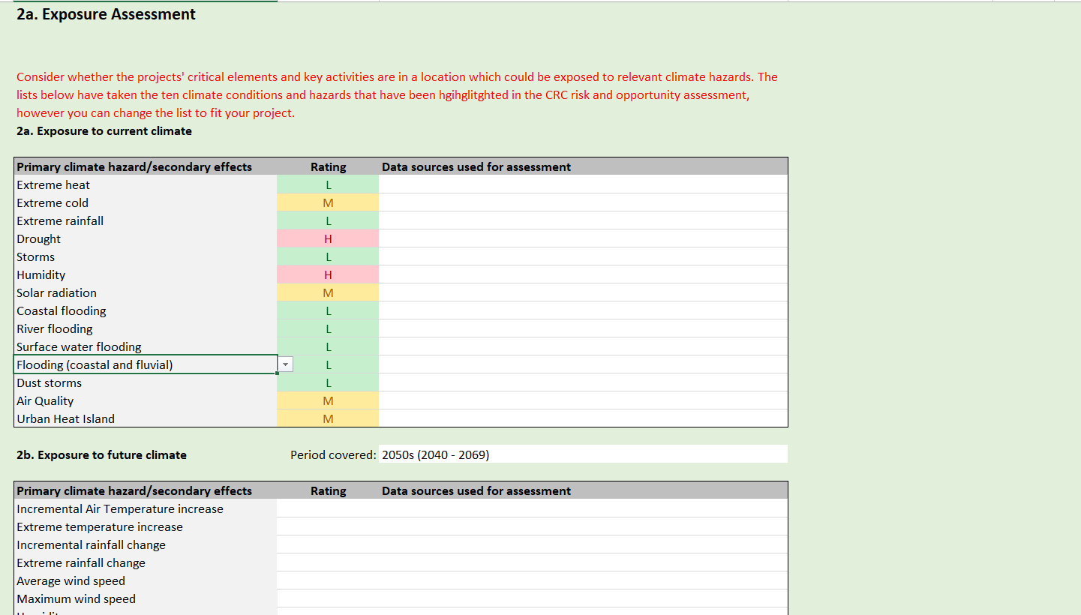
Step 4. Review risk likelihood
Review the matrix to understand the most important potential climate impacts in the current and future climate.
Step 5. Define risk descriptions, identify potential impacts and score  Define the risks associated with these hazards and actions to manage them, assign impact and likelihood scores for current and future time periods, and assign risk owners. | 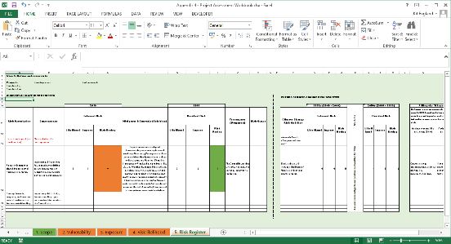

Time requirements
The amount of time needed to conduct an assessment will vary based on a range of factors, including prior knowledge of climate change, how it impacts on the project under consideration, and pre-existing work. However, the below table gives some rough estimates of the time required to complete the workbook. Note this may take place over a longer period which is needed for such a review to be comprehensive. It does not include the time required to assemble the relevant information to assess your project.
Activity | Time requirement
Define Project scope | 1 hour
Assess vulnerability | 2-3 days
Assess exposure | 1 day
Define and score risks | 2-3 days

Step by step guide to completing the workbook

Step 1: Setting the scope

Overview
Setting a clear scope is an important first step in performing a robust climate risk assessment. This will define the boundaries of what is assessed by the overall assessment.

Any assessment should cover the key assets and activities that support the project achieving its overall objectives and benefits. However, an assessment can also include activities or assets outside of your organisation, that your organisation does not own or control but that your project is connected to and dependent on, such as supply chains, highways and rail links. A properly defined scope requires a clear documented approach to what is included in four key areas:

- On-site assets and processes – the key assets or activities that happen on a project site
- Inputs – such as the supply of energy, raw materials or human resources
- Outputs – The physical things produced / functions undertaken for example R&D, property values, or products; and
- IT and Transport links - that connect the project to its surroundings and that can themselves be interrupted by extreme weather.

How to complete the worksheet

The workbook asks for some basic information about the overall project such as the name, project type, budget, any relevant partners, an overall description, planned lifetime of the project. It also asks for the future time period to be considered from the assessment. This is used to populate other tabs of the workbook.

As a general rule it is recommended that the assessment lifetime broadly mirrors the planned project lifetime though in some cases it may be necessary or useful to complete assessments for different time periods (e.g. for risks until a major refurbishment or renewal is planned).

Having completed the basic project information, work through each of the boxes on on-site assets and activities, inputs, outputs and transport links, documenting the most important areas which will be assessed.

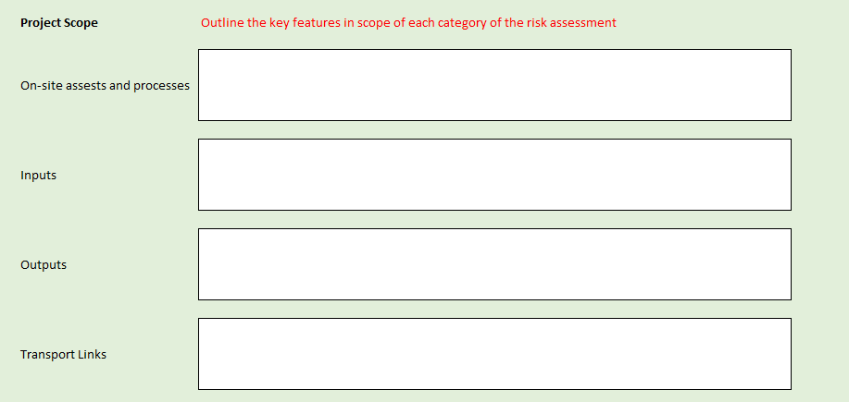

Step 2: Vulnerability assessment

Overview
The vulnerability assessment involves systematically assessing the degree to which the four elements of a project’s scope elements (assets and processes, inputs, outputs and transport links) are sensitive or susceptible to disruption or damage from a range of hazards, climatic conditions and secondary effects, as well as the size, scale and scope of disruption, relative to other similar projects, or functions of a business or organisation.

The workbook, does not include an assessment of 'adaptive capacity' (the ability to prepare, respond and recover), due to the challenges associated with quantifying it, and because the design and delivery of infrastructure or the built environment offers limited opportunities to change this. However, the ability of individuals and organisations to prepare, respond and recover to extreme weather events and climate change is significant, and should be considered as part of a more holistic approach to managing risk, as set out in step 5.

Example – Vulnerability for a food distribution centre/warehouse

For a food storage centre, the on-sites assets and processes (i.e. food storage) could result in spoiled food from overheating or flooding if affected by extreme air temperature increases, as well as rainfall change, sea level rise, as well as changes in humidity, solar radiation and the urban heat island, resulting in higher vulnerability ratings for these climatic variables. Alongside, other factors to consider would be the type and amount of food stored, and how large this is compared to other food distribution centres, as well as the broader consequences arising (e.g. disruption to wider deliveries and food supplies)

For the purposes of communication, it is also important to summarise the overall vulnerability, as well as the assumptions and evidence used to justify this assessment, and any areas identified where further investigation is needed.

How to complete the worksheet

For each of the four dimensions (on-site assets and processes, inputs, outputs, and transport links), consider the extent to which they are sensitive to each climatic variable or secondary effects, and score them appropriately. This is a subjective process, and can be an individual judgement or as a result of discussions with key members of a project team. Make sure to exclude any variables that are not relevant for your site or project type. As a guide, the different ratings are set out below:

- High vulnerability: Climate variable/ hazard may have significant impact on assets and processes, inputs, outputs and transport links.
- Medium vulnerability: Climate variable/ hazard may have slight impact on assets and processes, inputs, outputs and transport links.
- Low Vulnerability: Climate variable/ hazard has limited/no effect.

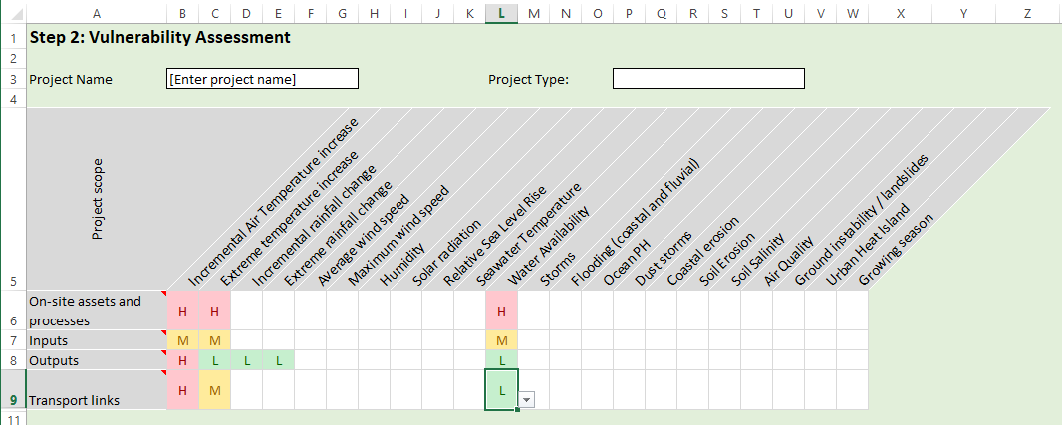

At this stage, don’t focus on the potential for the project to experience the hazards – this will be assessed in the next step. Once this is completed, complete the three boxes below.

As you work through this process, capture any assumptions or evidence used in the box on the worksheet. You should also document any areas where further investigation is needed. Once the process is completed, review the overall findings and summarise them in the box below. The summary should outline the most vulnerable aspects of the project and which climate hazards are of the most concern to the project.

Step 3: Hazard and exposure assessment

Overview

Once you have a sense of the project vulnerabilities, the next steps is to assess the degree to which the location of your project (and related functions) are exposed to the listed weather and climatic conditions, both now and at the end of the lifetime for which your project is planned. This assessment of different time periods is important as risks can manifest themselves at different points in time and it is important to understand this change over time to inform decision making about when adaptation options are required.

Example – Hazard and exposure assessment for a food distribution centre/warehouse

The food storage facility referred to above is going to be built in the West of Scotland, with a lifetime of over 20 years (though refurbishment and maintenance may be planned in between). Data from the UK Climate Projections show that the risk of future heatwaves is projected to significantly increase in the 2040s, meaning that the facility’s exposure is likely to increase over time.
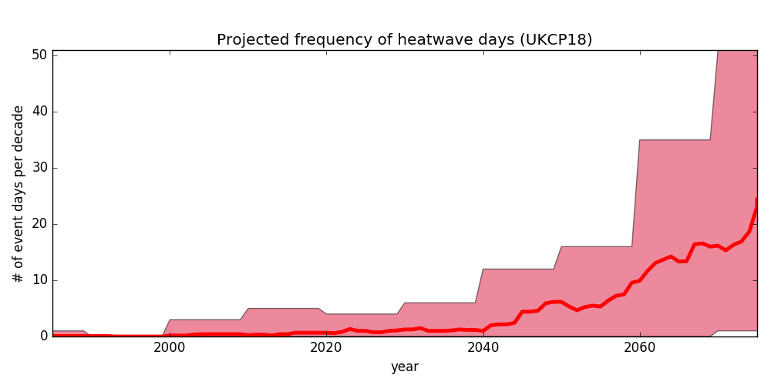

Assessing whether your site is exposed to climate conditions requires you to seek out information from trusted sources to inform your assessment. Some key national sources of information are:

- SEPA flood extent maps (using 1 in 200 year return period for now, 1 in 200+CC for future, or 1 in 1000) for surface water, river, coastal and groundwater flooding
- Dynamic Coast for future risk of coastal erosion
- The UK Climate Projections 2018 – Land projections and Sea Level Rise projections;
You may also be able to use local climate change risk assessments. For Glasgow City Region, Climate Ready Clyde published a thorough assessment of climate risks and opportunities in 2019.

Wherever possible you should also consider site-specific conditions such as low-lying areas that could be prone to surface water flooding and areas with a high degree of paving that may become urban heat islands.

How to complete the worksheet

Work through the worksheet to rate the project’s overall exposure to each climate hazard or secondary effect under current climatic conditions, scoring them as Low, Medium or High. Then repeat the assessment for exposure to future climatic conditions. In each case, make sure document the data sources used for the assessment or any notes or assumptions made.
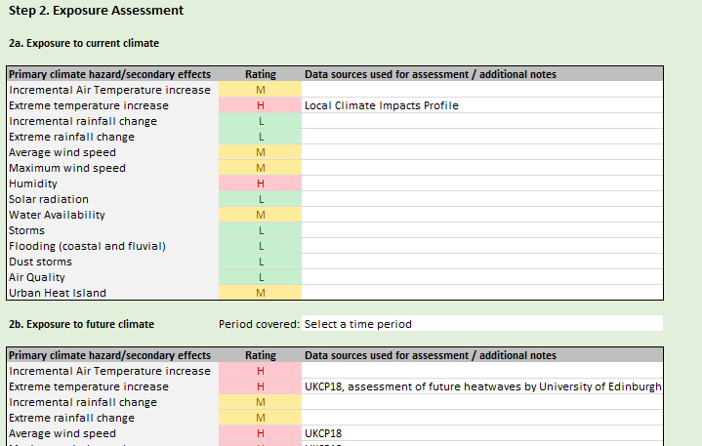

The bottom of the worksheet includes a space to describe the internal conditions for what constitutes a high, medium or low rating for exposure:

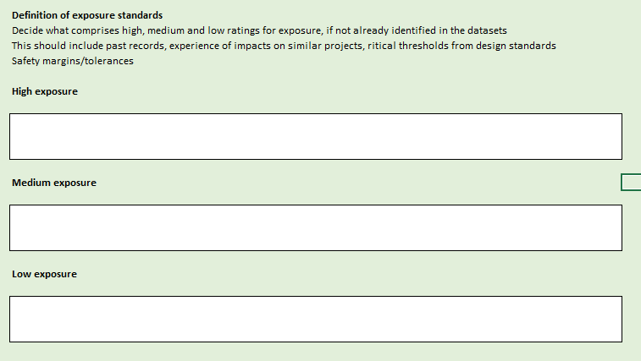

Step 4: Review climate risk likelihood

Overview:
Once the previous steps have been completed, the workbook automatically combines the scoring of the vulnerability and exposure assessments to generate a summary of the overall likelihood of climate risks to your project for the present day and the future climate period defined at the outset. This assessment provides a high level summary of the relevant climate risks, to support development of a project-specific climate change risk register and action planning. Weather and climatic conditions in green are low-risk, while those in red are the highest priority and should be the main focus of a climate change risk register and adaptation planning.

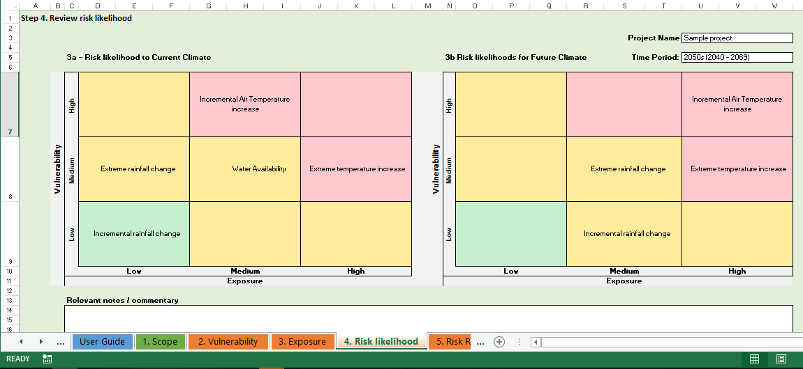

How to complete the worksheet

No information is required for this step of the process. However, a section is included for you to insert key observations or notes from the review process.

Step 5 – Develop the project’s climate change risk register

Overview
The last step of the risk assessment workbook involves translating the headline likelihoods of climate risks into a project specific risk register, with detailed risk descriptions which are scored for the risks your project faces today, and in the future. These assessments should explicitly account for the plans you already have in place or that are proposed to help manage risks, as well as how climate change will modify the risks and further adaptation options you could take. This analysis can be presented to the project steering group to support a decision on how to incorporate adaptation in your project.

How to complete the worksheet

Completing the worksheet is a two-stage process, which consists of assessing risks under the current and future climate.

Completing an assessment of climate risks for the current climate

Start by listing all the project-specific risks that might arise from the most significant climate risks identified. For each risk, you will need to complete:

- Risk description - including the cause of the risk (weather condition), the event and its effect on the project,
- Consequences – a description of the possible consequences as a result of the risk occurring (these could be financial, reputational, operational)
- Inherent risk scores – this is the likelihood and impact of the risk, without any treatments or controls in place to manage them
- Mitigants and controls (existing) – the existing activities your organisation has in place to reduce the likelihood of a risk occurring or to reduce its impacts
- Residual risk scores – The overall score once mitigants and controls are taken into account
- Treatments (proposed) - Any additional actions currently proposed to help manage the risk
- Risk owner – The relevant member of staff in the project who is responsible for managing the risk

Assessing future climate change risks

Once you have completed the current climate risk register, you will need to consider how climate change will affect the overall risk. For each risk, include a short narrative on how climate change may affect it. Then you should work through to score risk likelihood and impact for inherent risks and residual risks under climate change.

- Climate Change Risk Modifier –out how climate change will modify the risk as described
- Inherent risk scores –The likelihood and impact of the risk in the future climate (without any of the mitigants and controls from the baseline period)
- Residual risk scores – The residual risk in a future climate once mitigants, controls and proposed treatments are considered
- Filling the adaptation gap - Actions your organisation could take now and in future to strengthen existing mitigants and controls and to further reduce residual risk

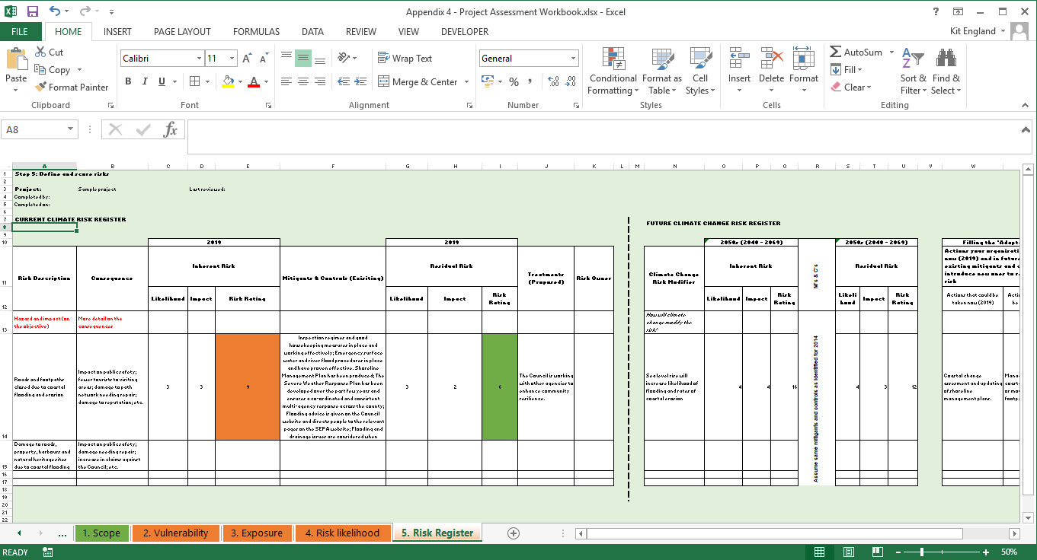

Risk Scoring
Each risk score involves ranking the likelihood of the risk occurring alongside the impact Scoring risks in step 5 uses a 5x5 matrix in line with EU guidelines. A sample matrix is included below for you to use. However, you may have your own scoring system you wish to use to better align to your own internal risk management processes.

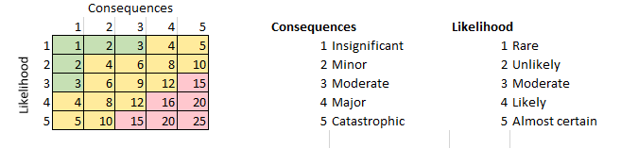
A more detailed set of criteria against which to judge likelihood and consequences of risks are included in p.40 - 41 of the EU guidelines for project managers.

Next steps and further information and support

Completing the workbook will provide a clearer understanding of the potential for climate change to affect a project in the long term, enabling consideration of potential adaptation options. The next step will be to decide which actions should be taken forward into an adaptation plan for a project. The selection and appraisal of adaptation actions is beyond the scope of this guidance, but advice can be sought from Adaptation Scotland. Please get in touch by emailing adaptationscotland@sniffer.org.uk

Supporting Resources

To support you in your assessments the following pieces of guidance or tools may also be helpful:

- SEPA Technical Flood Risk Guidance for stakeholders: http://www.sepa.org.uk/media/162602/ss-nfr-p-002-technical-flood-risk-guidance-for-stakeholders.pdf
- Dynamic Coast - The national coastal change assessment provides information on current and projected coastal erosion: http://www.dynamiccoast.com/
- SEPA Flood Risk Maps - http://www.sepa.org.uk/environment/water/flooding/flood-maps/
- UK Climate Projections 2018 - A range of guidance on how the climate will change through to 2080 under different emissions scenarios. Summaries for Scottish Regions are available here: https://www.metoffice.gov.uk/research/collaboration/ukcp/land-projection-maps
- HSE guidance on managing workplace temperature: http://www.hse.gov.uk/temperature/thermal/managers.htm
- Design for Future Climate - Report from InnovateUK setting out design principles for adapting buildings to climate change. Supported by 40 real world case studies exploring the changes needed to designs to be climate-ready. https://www.ukgbc.org/ukgbc-work/design-for-future-climate-innovate-uk-competition/

Vulnerability

- Flood Disadvantage in Scotland: http://www.gov.scot/Publications/2015/12/9621 - This dataset shows social and economic factors will affect the population's experience of all flooding types under a range of different flood return periods, accounting for climate change.
- CIBSE Weather Data sets - These datasets include Design Summer Years and Test Reference Years under climate change scenarios, allowing users to see how climate change will affect thermal comfort, and heating and cooling demands, allowing changes to be implemented. http://www.cibse.org/knowledge/cibse-weather-data-sets [Note - freely available datasets for 45 locations across the UK are avaiable from University of Exeter here: http://emps.exeter.ac.uk/engineering/research/cee/research/prometheus/downloads/

These should not be considered a comprehensive resource and you may need more detailed evidence to support your assessment

